PERSONAL DETAILS
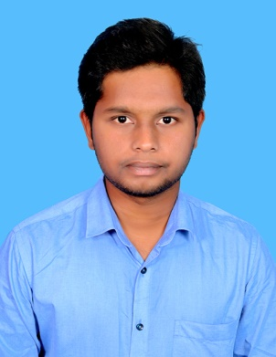
NAME: PRITHUVI RAJAN S
DATE OF BIRTH: 24/02/1997
AGE: 25
GENDER: MALE
FATHER’S NAME: SHANMUGAM M
PERMANENT ADDRESS:

13/218, Kamaraj nagar
Gonur(PO),
Mettur dam,
Salem District - 636404.
PHONE : 8870645521
EMAIL : prithivrajan98@gmail.com

CONTACT ADDRESS:

399/1A, Bathalapalli,
Opposite to Market,
Hosur - 641032.
PHONE : 8870645521
EMAIL : prithivrajan98@gmail.com

MOTHER TOUNGE: TAMIL .

LANGUAGES:
Read: Tamil, English.
Write: Tamil, English.
Speak: Tamil, English.

ACADEMIC RECORD

Course | Institution | University /  Board | Year of  Completion | CGPA /  Marks %
B.E.  Mechanical  XII  X | Karpagam College of Engineering, Coimbatore  MALCO MATRIC HR SEC SCHOOL, Mettur  MALCO MATRIC HR SEC SCHOOL, Mettur | Anna University  State Board  State Board | 2019  2015  2013 | 8.72  88  95

CERTIFICATIONS:
- Attended a Hands-on-training on Dismantling and Assembly of I C Engines organized by SAE INDIA .
- Attended a workshop on Current Trends in Sequential Micro Machining Process on a Single Machine Tool held at CIET.
- Participated in Guinness World Record Attempt for largest Human Image of a Music Instrument.

TRAINING DETAILS:
- Undergone In-Plant Training at ROOTS Industries India Ltd.
- Completed training on AUTO CADD.

FIELD OF INTEREST:
- Pump Maintenance.
- Pnuematics and Hydraulic Operations.
- Utility Engineering Operations.
SOFTWARES KNOWN:
- ANSYS
- SOLIDWORKS
- MS office
LANGUAGES : C-Program.

PROJECT WORKS DONE:
- Fabrication of GENEVA Mechanism.
- Performance Characteristics Analysis of Vehicle Sub frame Structure and Validation through FEM Approach.
- Published My Journal "Performance Characteristics Analysis of Vehicle Sub frame Structure and Validation through FEM Approach" in IJIRSET.
Ref e-ISSN: 2319-8753, p-ISSN: 2320-6710, Volume 9, Issue 12, December 2020.

PROFESSIONAL EXPERIENCE:
- Completed One Year Trainee in KANSAI NEROLAC PAINTS LTD, HOHOSUR
WORK : Mechanical Maintenance and KUKA Robot Operation. (2020 - 2021).

I, PRITHUVI RAJAN S, do hereby confirm that the information given above is true to the best of my knowledge.

Place: Signature
Date:

